Jalapeño Jelly, Text to Tables, and Tables to Text assignment.
Juliana Hill
9/15/12

Jalapeño Jelly
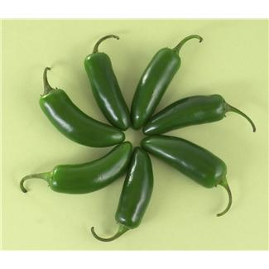 | 3 Jalapeño peppers | 4 Bell peppers
 | 5 cups sugar | 1 cup white vinegar
 | 1 package or bottle of pectin
 | Open the peppers and remove seeds and veins. Run peppers through food processor until finally chopped. (I usually add the vinegar to the food processor with the peppers). Add all juices to a pot with the sugar and boil for 10 minutes. Remove from heat, add pectin, and continue boiling until it reaches the hard boil stage. Boil for 1 minute. Pour into sterile jars to within ½ inch of the top. Put on cap, screw band firmly tight. Process in boiling water bath for 5 minutes. Makes 5 ½ pints.

Color | Number | Exercise
Red | One | Power Walking
Yellow | Two | Jogging
Green | Three | Swimming
Pink | Four | Hiking
Blue | Five | Stair Master
Orange | Six | Elliptical
Tangerine | Seven | Weights

Color Number Exercise
Red One Power Walking
Yellow Two Jogging
Green Three Swimming
Pink Four Hiking
Blue Five Stair Master
Orange Six Elliptical
Tangerine Seven Weights

