Mary jane Figueroa

10/5/2012

Paint assignment

Wanted for Great Teaching

MJ Figueroa

My Biography

My name is Mary Jane Figueroa. I am the school nurse at Thompson E. S and Bozarth.

This is my 4th year with the CCSD. I am also currently working in a Rehab Facility as Charge Nurse.

I am married with 3 children. My hobbies include photographyC:\Documents and Settings\student\Local Settings\Temporary Internet Files\Content.IE5\ATUNA1IJ\MC900411946[1].wmf and cooking. 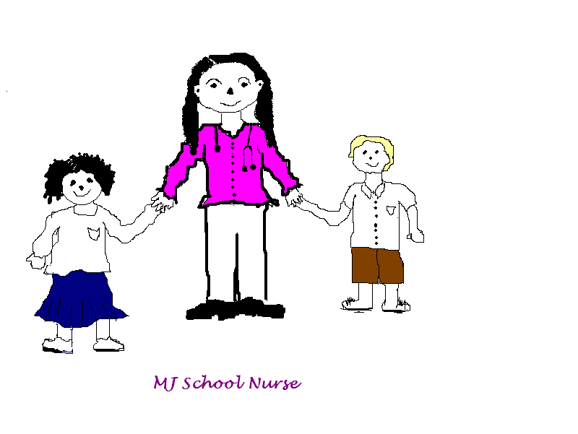

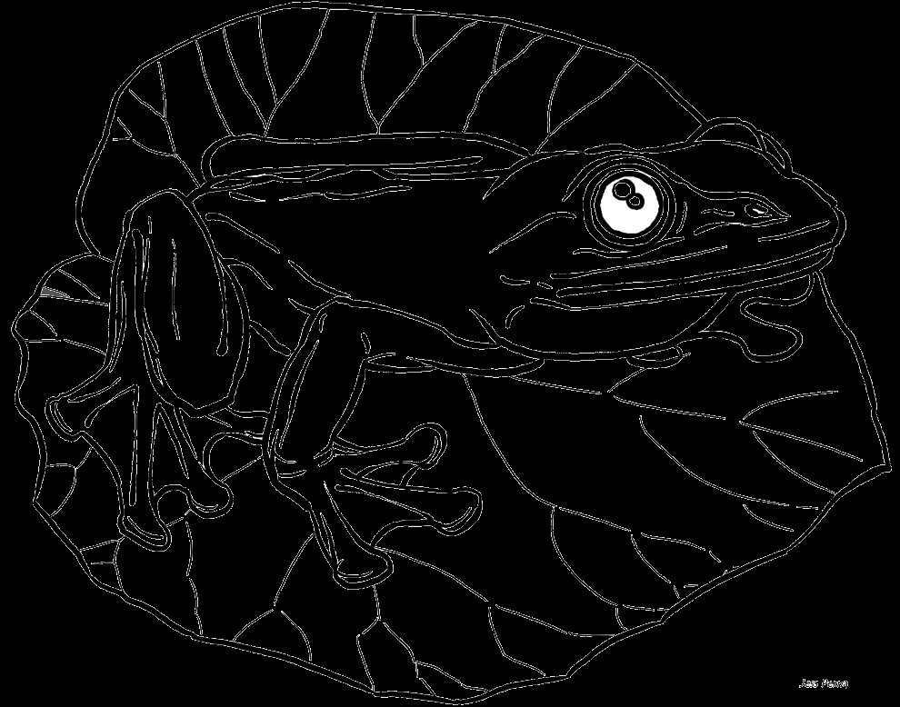

Frog coloring

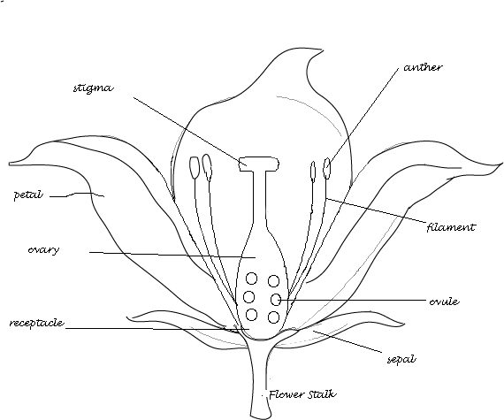

Labeled the flower

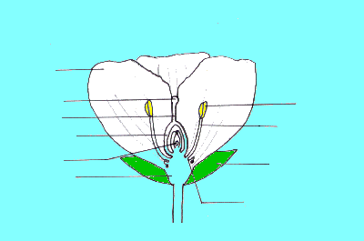

Unlabeled the flower

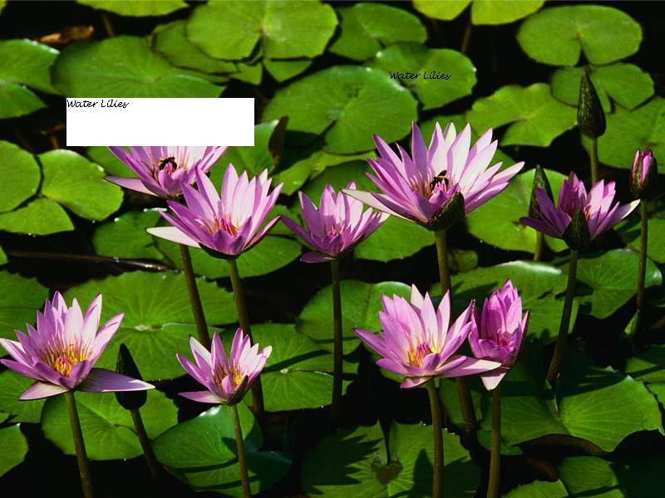

Add Text

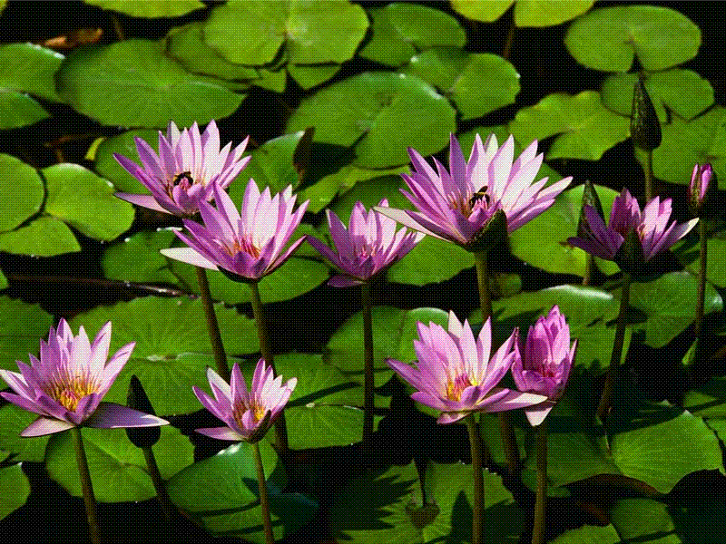

Change format “ gif format”

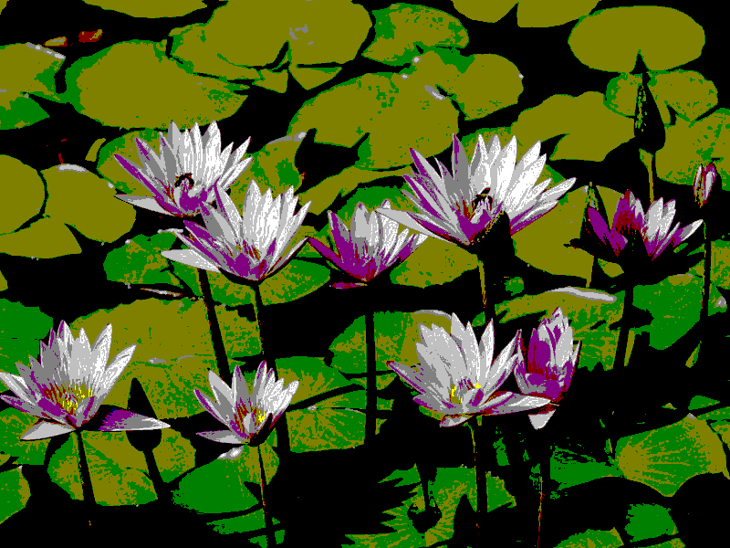

Change format “ Bmp format”

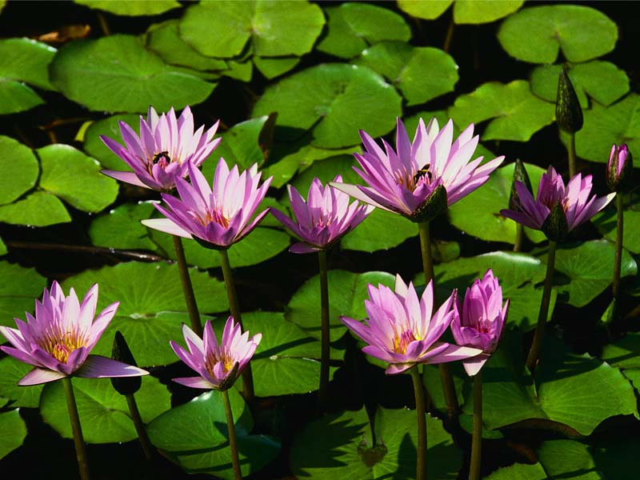

Original

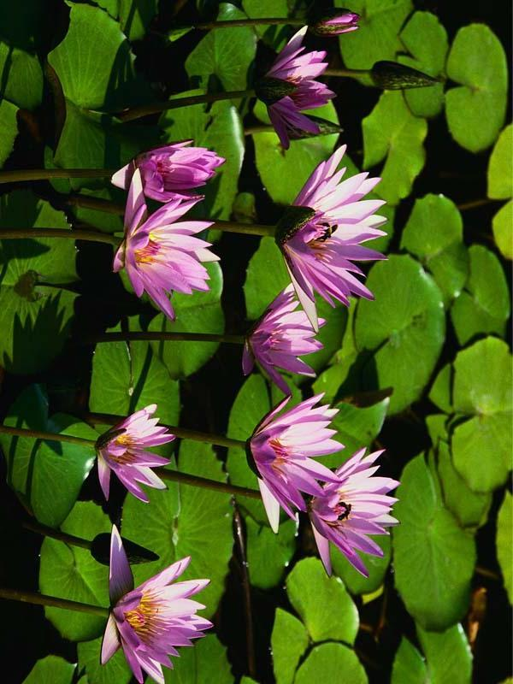

Flip and Rotate



Original

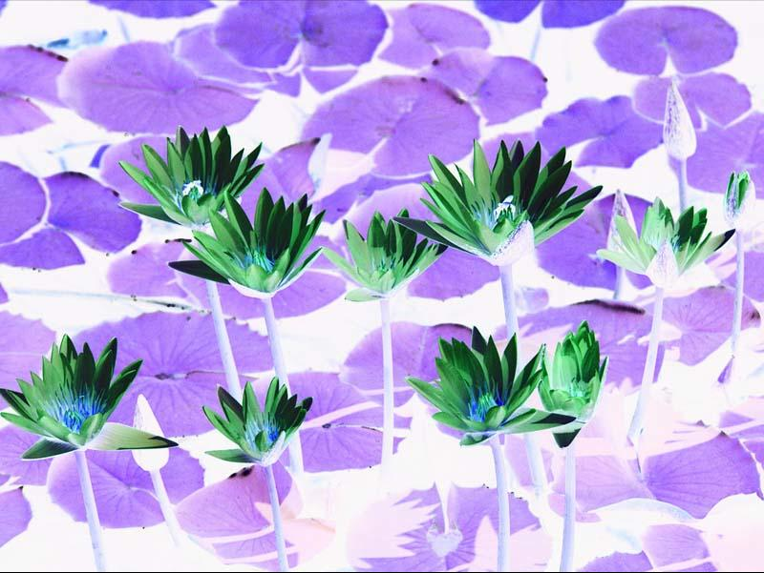

Inverted Color



Original

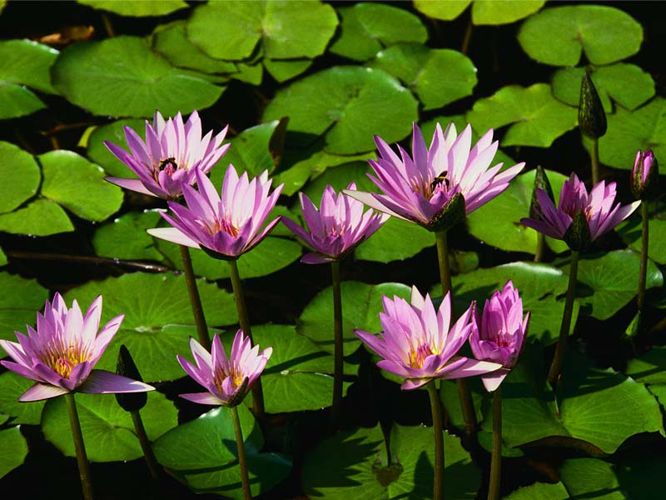

Crop Image



Original

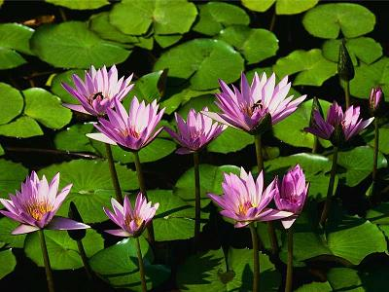

Reduce size