Mitosis
Activity 2

Name ________________________________________ Period __________________

Look through the microscope at the prepared slides of onion root tips. The tip of the root is where growth occurs, thus this is the place where mitosis occurs. The image you see should look something like the example below.

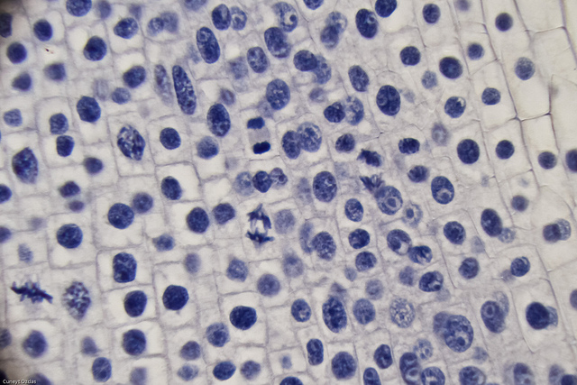
The nuclei have been stained so you can see them easily. Normally, they appear clear.

Your task is to locate and draw a cell in each phase of mitosis. Make your drawings on the other side of this page in the space provided.,

Mitosis

Name ________________________________________ Period __________________

Telophase
Anaphase
Prophase
Metaphase
Interphase

