Mitosis
Activity 3

Name ________________________________________ Period __________________

- Prepare slides of onion root tips if possible. If not, use prepared slides of onion root tips. If these are not available, use the images; use the internet to find more images if needed.

- Count the number of cells in each phase of mitosis. Record your number in the chart below.

Cells in Mitosis | Number
Interphase
Prophase
Metaphase
Anaphase
Telophase

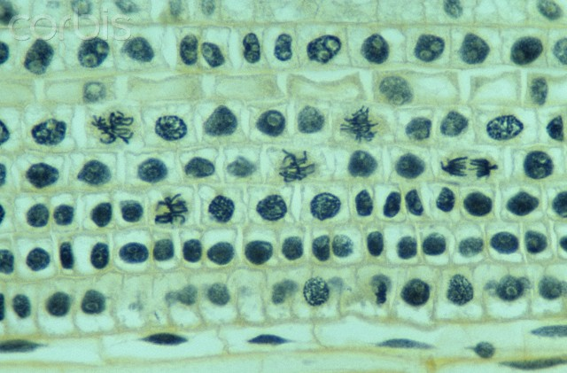
- Use Excel to organize the data from all groups and to make a graph of the time in mitosis.
- Use a formula to calculate the time in each phase of mitosis; assume the onion cell divides every two hours.

Sample set of data
 | Group
Phase | 1 | 2 | 3 | 4 | 5 | 6 | 7 | 8 | Total | Percent | Time In Phase (minutes)
Interphase | 54 | 40 | 60 | 30 | 80 | 32 | 37 | 42 | 375 | 50% | 60.48
Prophase | 43 | 63 | 32 | 25 | 4 | 1 | 5 | 12 | 185 | 25% | 29.84
Metaphase | 12 | 1 | 44 | 17 | 5 | 2 | 3 | 14 | 98 | 13% | 15.81
Anaphase | 5 | 3 | 7 | 7 | 1 | 3 | 3 | 8 | 37 | 5% | 5.97
Telophase | 13 | 3 | 16 | 5 | 2 | 2 | 2 | 6 | 49 | 7% | 7.90
Total | 128 | 112 | 162 | 88 | 97 | 46 | 57 | 90 | 744

Sample chart of the number of cells in each phase of mitosis

Sample chart of time in each phase of mitosis

